Celebrating 50 Years of Chemical Plant Commissioning at Leeds

This year we celebrate the 50th anniversary of the Chemical Plant Commissioning short course at the University of Leeds. This IChemE-approved training course was the brainchild of Prof George Sachs, previously of ICI, who started the course in the 1970s. More recently the course was run by Dr Peter Snowdon who was director for the majority of his career. The current director, Prof Michael Fairweather, took over the course in 1999 and continues in that role today. He is ably assisted by Dr Martin Pitt, as Deputy Course Director, who has been associated with the course since 1988, and Prof Paul Lunt, acting as Deputy Course Director (Industrial), who has a long and distinguished career leading the commissioning, start-up and operation of over 20 projects across a range of technologies world-wide.
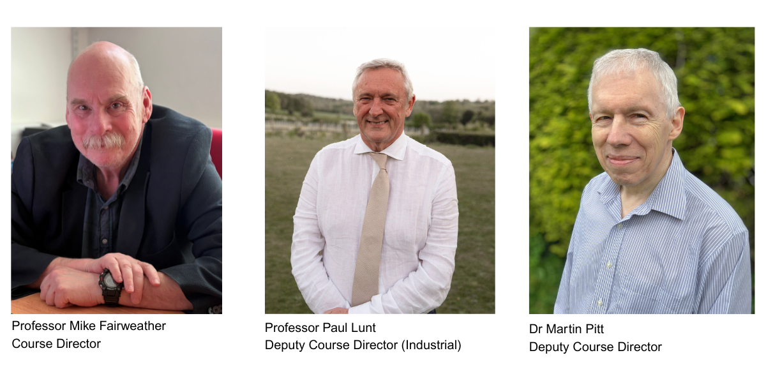

The three-day course teaches how to safely and effectively bring a new or modified chemical process plant from construction through to stable operation, and is aimed at process engineers, project engineers, commissioning engineers, and plant managers in the chemical, petrochemical and related industries. The success and longevity of the course is due to the fact that it has always maintained its industrial perspective and relevance, with the majority of presentations on the course being given by industrialists and consultants who are practicing experts in their field. The presentations on the course are also generic, giving the course wide applicability across all industries and many commissioning roles. To date, approximately 2000 attendees have benefited from the course.

Teaching on the course combines a mixture of formal lectures and tutorial group exercises, as well as a number of case studies, currently covering pre-commissioning, commissioning, planning and schedules, plant completion, risk-based commissioning, start-up, measurement and control systems, legal and environmental issues, safety and top tips from industry experts. Comprehensive notes are provided that are not only of value during the course but also provide reference material for future use.

Another key to the success of the course is its reliance on, and response to, feedback from attendees. Any course such as this has items that are missing, or less value than others, and feedback has allowed us to modify the course over the years to improve its benefit of participants. As a consequence, the course has evolved over the years, not drastically year-on-year, but comparing the course now with that from only 10 years ago, it has changed considerably.

Although in its 50th year, the course continues to be well attended, with approximately 50 participants annually. Given its success, and usefulness, it is planned to continue the course into the future, but that can only be achieved through the continued input from industry experts, and we would like to acknowledge the significant contribution of current and past presenters on the course to its success. And it would be amiss if we also did not acknowledge those in the Faculty of Engineering and Physical Sciences Continuing Professional Development, Conferences and Events Service who take on much of the hard work associated with any course such as this.

So, we celebrate 50 years of the Chemical Plant Commissioning short course, and look forward to another 50 years of providing training and skills development to employees of the wide range of industries involved in commissioning activities.

Course Director
Professor Mike Fairweather, School of Chemical and Process Engineering,
University of Leeds
Deputy Course Director
Dr Martin Pitt, Consultant
Deputy Course Director (Industrial)
Professor Paul Lunt, Commissioning, Start-up & Operational Readiness Consultant and
Visiting Professor, University of Leeds

